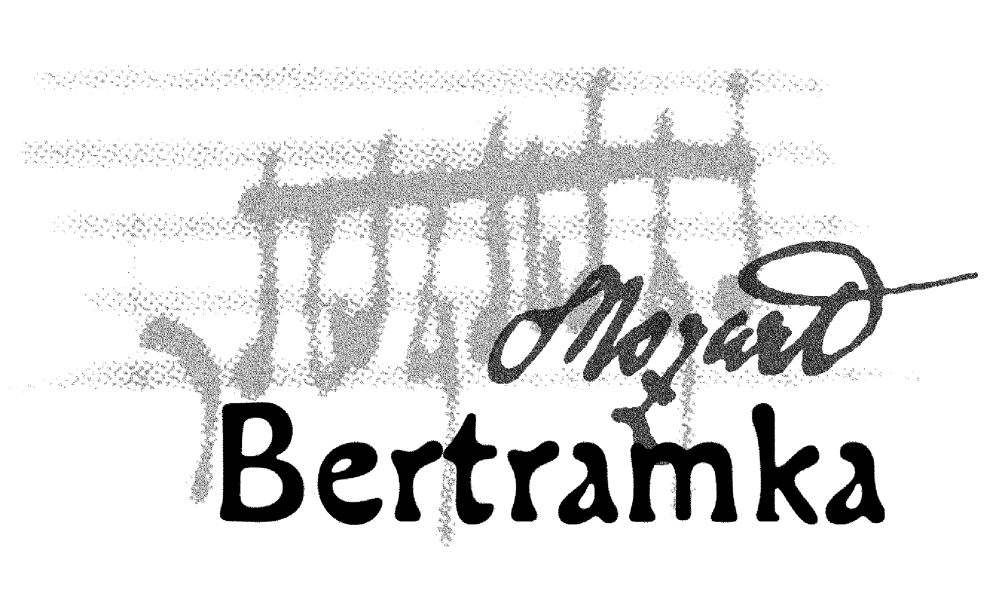
CONCERTS AT BERTRAMKA

AUGUST 2007

2.Thu GARDEN CONCERT
7 p.m. Chamber Music at Bertramka
Mozart and Slavonic Masters

5.Sun GARDEN CONCERT
7 p.m. Opening concert of French horn festival

7.Tue Quartetto con flauto (flute, violin, cello, piano)
5 p.m. J. G. Albrechtsberger: Quatuor
W. A. Mozart: Duo for Violin and Cello, K. 423
W. A. Mozart: Andante in C major, K. 315
J. Haydn: Divertimento in B flat major
J. J. Quantz: Trio Sonata in C minor

9.Thu Yoko Kato – piano, Monika Vrabcová – violin
5 p.m. W. A. Mozart: Fantasia in C minor, K. 475
W. A. Mozart: Sonata in C minor, K. 457
W. A. Mozart: Sonata in B flat major for piano and violin, K. 378
F. Schubert: Sonata in E flat major, D. 664

11.Sat GARDEN CONCERT – Mozart and Jazz

7 p.m. Epoque Quartet (1st violin, 2nd violin, viola, cello)
F. X. Richter: Adagio and Fugue
W. A. Mozart: String Quartet in C major „Dissonance“, K. 465
D. Balakrishnan: Spiderdreams
J. Hendrix: Gypsy Eyes
J. Kučera: My funny Valentine
D. Gillespie: A Night in Tunisia
P. Matheny: Jaco

14.Tue Czech String Duo (violin, cello)
5 p.m. W. A. Mozart: Duo in G major, K. 423
N. Paganini: Duetto concertante Nr. 3 in A major
O. Kvěch: Duo (1983)
J. Fiala: Duett in C major, WV 4.17
B. Martinů: Duo No. 2

15.Wed GARDEN CONCERT
7 p.m. Opening Concert of AD HONOREM MOZART Festival
Konrad Jarnot – baritone, Zdena Kloubová – soprano
W. A. Mozart: Selection of songs: “Zufriedenheit, An Chloë, Als Luise…,
Das Veilchen, Warning”
W. A. Mozart: “Ridente la calma, Oiseaux si tous les ans,
Dans un bois solitaire, Abendempfindung”
Songs about love by famous composers:
J. Haydn: Die Landlust, Schäferlied
L. van Beethoven: Ich liebe dich
F. Schubert: Volksliedchen
L. van Beethoven: “An die ferne Geliebte“
Arias and Duets from Mozart’s operas:
“Un motto di gioja” (song for Susanna from the Marriage of Figaro)
“Deh vieni a la finestra” (aria of Don Giovanni)
Duet of Susanna and Count (Marriage of Figaro)
“Rivolgete a lui lo sguardo” (aria of Guglielmo from the opera Cosi fan tutte)
Aria of Susanna (Marriage of Figaro)
Duet of Pamina and Papageno (Magic Flute)

18.Sat GARDEN CONCERT
7 p.m. Prague Basson Band
W. A. Mozart: Divertimento No. 1 in B flat major, K. 439b
W. A. Mozart: Divertimento on theme´s from the operas the Magic Flute
and the Marriage of Figaro
J. N. Hummel: Quartet in E flat major (one movement)
G. Rossini: Largo al factotum (Il Barbiere Di Siviglia)
J. Weissenborn: Selection of 6 pieces
E. Bozza: Divertimentos for Three Bassoons
P. Arden-Taylor: Carry On Bach!
A. Skirrow: Variations on A Drunken Sailor

19.Su GARDEN CONCERT – “Divertimenti in Prague“
3 p.m. Herold Quartet (1st violin, 2nd violin, viola, cello)
W. A. Mozart: String Quartet in C major, K. 465 “Dissonance”
B. Smetana: String Quartet in D minor, No. 2
F. Schubert: String Quartet in D minor “Death and the Maiden”

19.Su GARDEN CONCERT – “Divertimenti in Prague“
7 p.m. M. Nostitz Quartet (1st violin, 2nd violin, viola, cello)
W. A. Mozart: String Quartet in F major, K. 590
L. van Beethoven: String Quartet in C minor, Op. 18 No. 4
B. Smetana: String Quartet No. 1 in E minor “From My Life”

21.Tue „Japanese Musicians and W. A. Mozart in Prague“
5 p.m. Yoshiyuki Daikai – violin, Noriko Kitagaki – violin, Miroslav Sekera – piano
G. F. Handel: Sonata for Violin and Piano No. 6 in E major, Op. 1 – 15
E. Ysaye: Sonata for Violin Solo No. 3 in D minor „Ballada“, Op. 27 – 3
Z. Fibich: Poem
W. A. Mozart: Concerto for Violin and Piano in D major, K. 218, 1st movement
W. A. Mozart: Sonata in G major for Piano and Violin, K. 301
P. I. Čajkovskij: Melody, Op. 42, No. 3
B. Smetana: Two Duos „From my Homeland“ for Violin and Piano

23.Thu Musica Dolce Vita (mezzo–soprano, flute, harp)
5 p.m. A. Vivaldi: Aria „Si fulgida per te“ from the Oratorio Juditha triumphans
Aria „Sposa son disprezzata“
G. F. Händel: Passacaglia for Harp Solo
Aria „Ah, mio cor“ from the opera Alcina
W. A. Mozart: Rondo in D major
Aria „Als Luise die Briefe ihres ungetreuen
Liebhabers verbrannte“, K. 520
Andante in C major for Flute and Harp
Ave verum corpus, K. 618
Laudate Dominum, K. 339
Aria „Komm, liebe Zither“, K. 367
Aria „Ridente la calma“, K. 210
Sonata in C major
H. Berlioz: Vaudeville from dramatic Symphony Romeo and Juliet
F. Chopin: Variation on Rossini Theme
C. Saint-Saens: Une flute invisible
Swan for Harp Solo
Cl. Debussy: The Girl with Flaxen Hair
A. Lloyd-Weber: Pie Jesu from Requiem

24.Fri „Japanese Musicians and W. A. Mozart in Prague“
5 p.m. Ayaka Omura – violin, Pavel Eret – violin, Suzanna Hlinka – piano
H. Eccles: Sonata in G minor for Violins and Piano
W. A. Mozart / F. Kreisler: „Rondo“ in G major from „Haffner Serenade“
A. Dvořák / F. Kreisler: Slavonic Dance in E minor, Op. 72 – 2
M. Ravel: „Gipsy“
E. Grieg: Sonata in C minor for Violins and Piano, Op. 45
A. Dvořák: Mazurek, Op. 49

25.Sat GARDEN CONCERT – „Japanese Musicians and W. A. Mozart in Prague“
5 p.m. Czech Philharmonic Quartet and their guests
(1st violin, 2nd violin, viola, cello)
Noriko Kitagaki – violin, Pavel Eret – violin
A. Vivaldi: Double Concerto in D minor for two Violins, Strings and Harpsichord,
F. I. 100
J. S. Bach: Double Concerto in D minor for two Violins, Strings and Harpsichord,
BWV 1043
W. A. Mozart: String Quartet in E flat major, K. 428

26.Su GARDEN CONCERT – “Divertimenti in Prague“
3 p.m. Stamic Quartet (1st violin, 2nd violin, viola, cello)
W. A. Mozart: String Quartet in B flat major, K. 458 “The Hunt”
L. Janáček: String Quartet No. 1 “Kreutzer”
A. Dvořák: String Quartet in F major, Op. 96 “American”

26.Su GARDEN CONCERT – “Divertimenti in Prague“
7 p.m. Pražák Quartet (1st violin, 2nd violin, viola, cello)
W. A. Mozart: String Quartet in D major, K. 575
J. Brahms: String Quartet in C minor, Op. 52 No.1
A. Dvořák: String Quartet in A flat major, Op. 105

27.Mon GARDEN CONCERT
7 p.m. Young Prague Chamber Orchestra
A. Dvořák: Wind Serenade in D minor, Op. 44
W. A. Mozart: Serenade in E flat major, K. 375

28.Tue Petr Bernášek – violin, Petr Jiříkovský – piano
5 p.m. G. Tartini: Sonata in G minor „Devil’s Trill“
W. A. Mozart: Sonata in G major, K. 301
F. Schubert: Rondo in A major for violin and piano
E. Grieg: Sonata for violin and piano in C minor, Op. 45

30.Thu EuroArt Praha – Season of Laureates 2007
5 p.m. Kateřina Soukalová-Váchová – clarinet, Martin Fila – piano,
Vilém Veverka – oboe
W. A. Mozart: Sonata in E minor, K. 304 (transcription for oboe)
F. Divienne: Sonata for Clarinet
W. A. Mozart: Aria „Sperai viccini il lido“, K. 368
Aria „Ah se in ciel, benigne stelle“, K. 538 (arr. for oboe
and piano)
B. Martinů: Sonatina for clarinet and piano
J. Ibert: Aria

________________________________________________________________________

BERTRAMKA – MUZEUM W. A. MOZARTA, Mozartova 169, Praha 5
Telefon: 257318461, 257317465, Tel / fax: 257316753,
e-mail: mozart@bertramka.cz, www.bertramka.com

